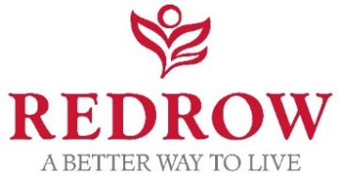
Application form for Kingsbourne Community Fund – fund total £5000
Your name

Organisation/applicant name
Address of organisation/ applicant
Your role/connection to organisation/ applicant
Email

Daytime tel (mobile & landline)
Total amount requested and how it would be used
Breakdown of costs, if applicable

If part of a larger project, what is total amount of funding required?
Please include details here of how the rest of the project will be funded, if applicable and associated timescales
Brief details about your project

How will the project benefit your community?
If you are seeking funding for a building project, including refurbishment or an extension, do you have the necessary permissions and infrastructure in place? Does your project need approval from a third party, eg. local authority. Explain briefly.
If we approve your funding request will your project be in a position to proceed? If not, why not?
Approximately how far is your project from our development: Kingsbourne, Waterlode, Nantwich, Cheshire, CW5 5BS
How did you find out about the fund? Please state, eg. newspaper article, online source, word of mouth, previous recipient.

Guidance on completing your application

- Please return your completed application form to redrowfund@activepr.co.uk by midnight on the 4th September 2020.

- We aim to let you know the outcome of your application within a month of the deadline. If there are any delays, we will keep you updated.

- We can’t accept supporting documents, so please make sure all relevant information you wish to share is included in the application form.

- Please note that Redrow will try and help a variety of groups and spread the funds as widely as possible, so we’d encourage applicants to take this into account when applying for funding.
- Remember to include details of how you would use the funds requested. This could be to purchase equipment, hire facilities or contribute towards running costs.

- If your request is part of a larger/ long running project with a higher budget, please include a breakdown of costs and timescales involved. Redrow may be able to support an element of your project alongside other local causes.

- Information from the application form will be collated by Active PR and shared with Redrow Homes for the purposes of processing your application

- Successful applicants will be required to take part in PR/promotional activity for the community fund.

