Community Fund application form
Your full name:
Your email address:
Your telephone number:
Name of the applicant/organisation that you wish to nominate:
Address of the applicant/organisation:
Email address of the applicant/organisation:
Telephone number of the applicant/organisation:
Details about the project:

Total amount requested (including breakdown of the costs):
How the project will benefit the community:

How did you find out about the fund?

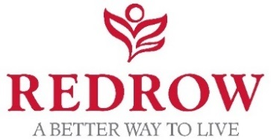
Guidance on completing your application

- Please return your completed application form to communityfund@wpragency.co.uk by Sunday 19 May 2019.

- We aim to let you know the outcome of your application within a month of the deadline. If there are any delays, we will keep you updated.

- We can’t accept supporting documents, so please make sure all relevant information you wish to share is included in the application form.

- Please note that Redrow will try and help a variety of groups and spread the funds as widely as possible, so we’d encourage applicants to take this into account when applying for funding.
- Remember to include details of how you would use the funds requested. This could be to purchase equipment, hire facilities or contribute towards running costs.

- If your request is part of a larger/ long running project with a higher budget, please include a breakdown of costs and timescales involved. Redrow may be able to support an element of your project alongside other local causes.

- Information from the application form will be collated by WPR and shared with Redrow Homes for the purposes of processing your application

- Successful applicants will be required to take part in PR/promotional activity for the community fund.

